NETWORK LAYER:-
- it has two main functions.they are
- breaking up segments into network packets
- reassembling the packets on the recieving end
- the other is routing packets by discovering the best path across physical network
- Here the data is in the form of packet
- It deals with LOGICAL ADDRESSNG,PATH DETERMINATION,ROUTING

DATA LINK LAYER:
- Here tha data is in the form of frames
- it contains ip address of sender and reciever.

ETHERNET FRAMES:-
- In computer networking an ethernet frame is a data link layer protocol data unit and uses the underlying ethernet physical layer transport mechanism
- in other word a data unit on an ethernet link trasports an ethernet frame as its payload.
- An Ethernet frame is preceded by a preamble and start grame delimiter(STD),ehich are both part of the ethernet packet at the physical layer.
- Each ethernet frame starts with an ethernet header,which contains destination and source MAC addresses as its first two fields
- The middle section of the frame is payload data including any headers for other protocols carried inthe frame
- The frame ends with a frame check sequence(FCS),which is a 32-bit cyclic redundancy check used to detect any in-transit corruption of data.

STRUCTURE:-
- Adata packet on the wire and the frame as its payload consist of binary data.
- Ethernet transmit data with the most-significant octet first,within each octet.however,the least-significant bit is transmitted first.
- The internal structure of an ethernet frame is specified in IEEE 802.3.
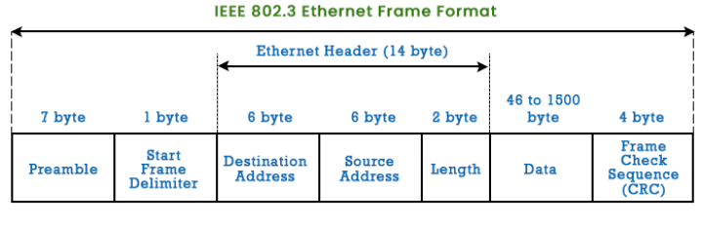
- The table below shows the complete ethernet packet and the frame inside,as transmitted,for the payload size up to the MTU of 1500 octates.
- Some implimentations of Gigabit ethernet and other higher speed variants of ethernet support larger frames known as jumbo frames

